

Request for proposal (RFP):

Learning management system



[Organization's name]

[Phone number]

[Official website]

[Email address]

[Linkedin]

[Organization's address]

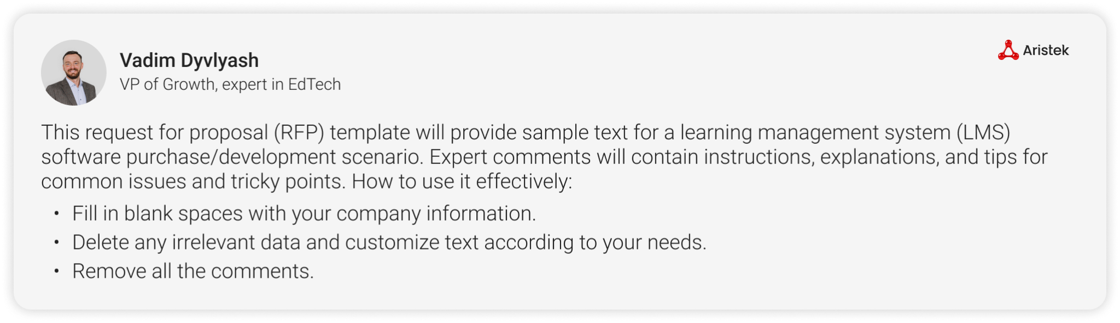

Table of contents

Introduction

Company information

Project overview

LMS requirements

Data privacy and security

Performance benchmarks

Costs and budget

Proposal guidelines

Proposal format and structure

Evaluation criteria

RFP timeline

Contact information

Terms and conditions

# Introduction

Enter text is currently accepting proposals for the development, implementation, training, ongoing support, and maintenance of a learning management system (LMS).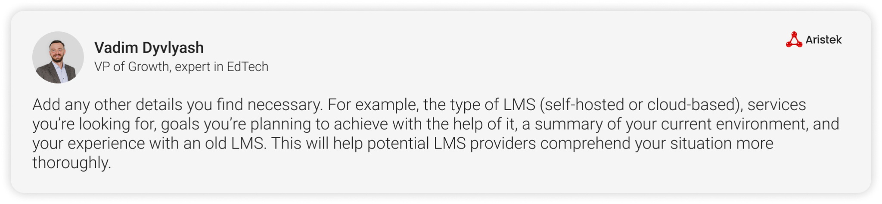

The purpose of this RFP is to invite eligible vendors to submit proposals for the provision of a comprehensive learning management system (LMS) that meets the functional and technical requirements of our organization, conduct a fair evaluation based on the prescribed criteria, and select the candidate(s) who is/are the best fit for the project.

## Company information:

Enter text is a Enter text company founded in Enter text. We provide Enter text services to Enter text. They include Enter text, Enter text, Enter text.

Our mission: Enter text

Our vision: Enter text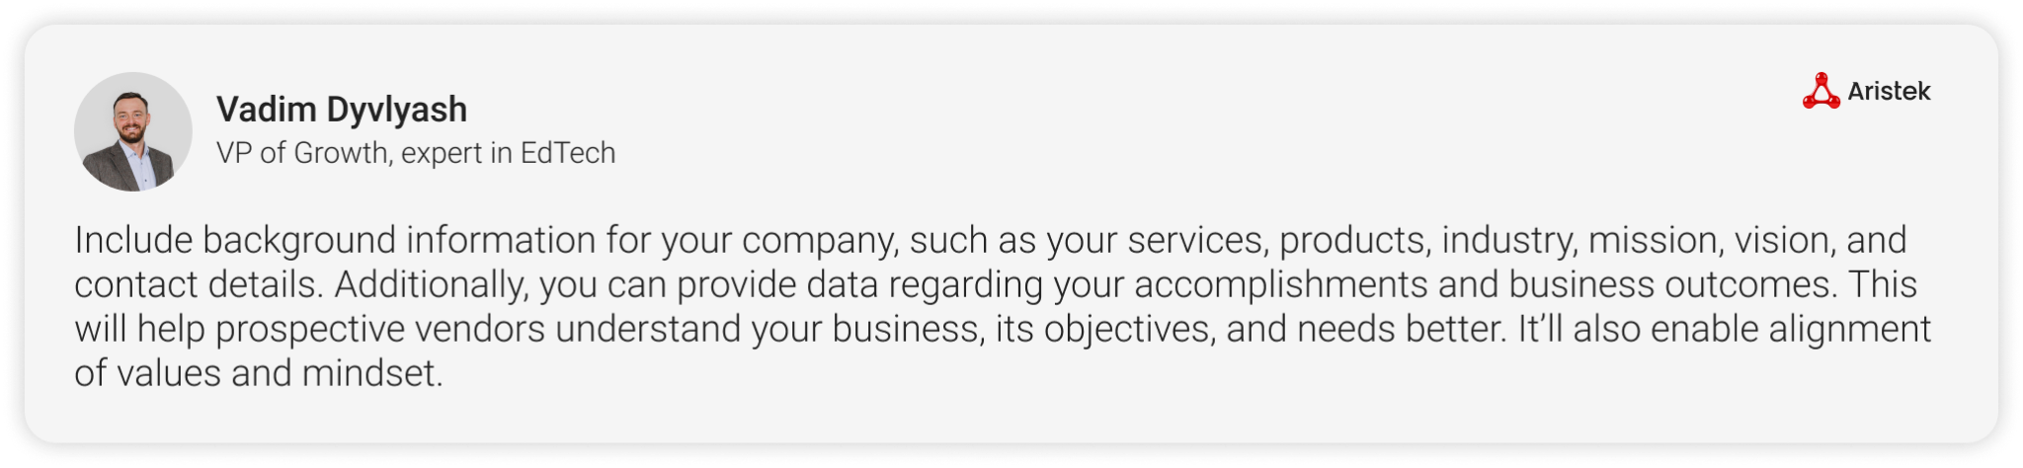

# Project overview

The purpose of this project is as follows: Enter text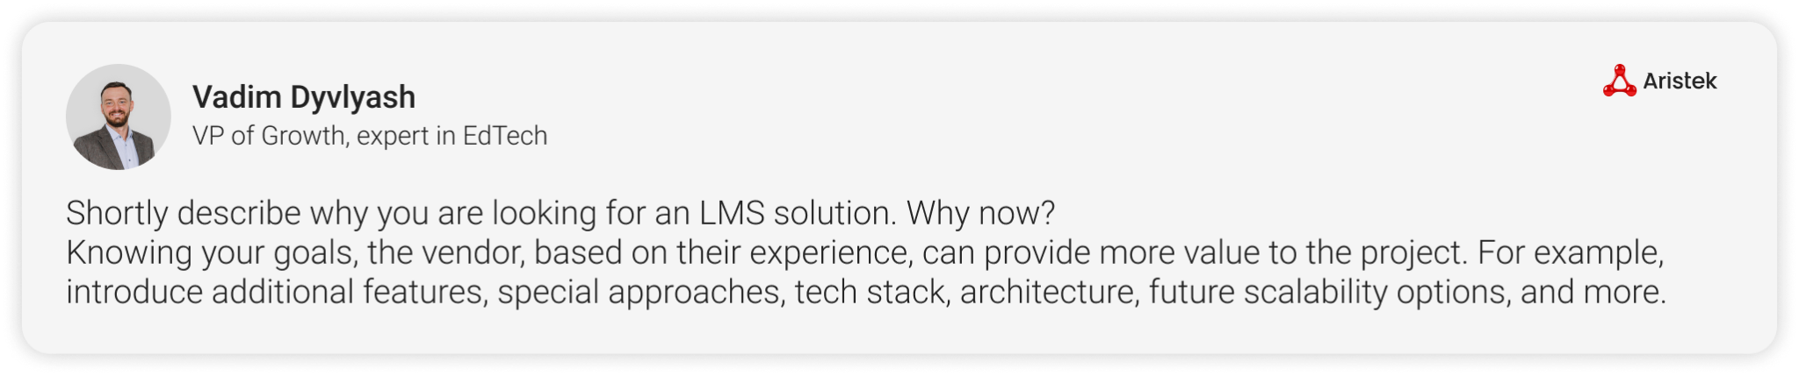

Goals and objectives: Enter text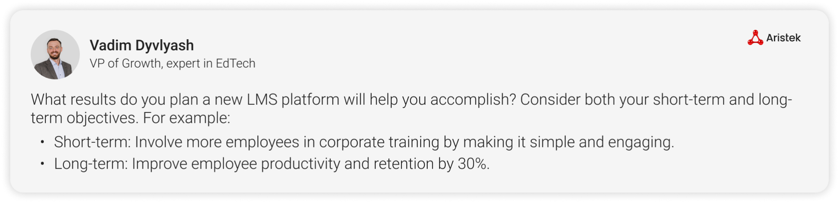

The scope of work: Enter text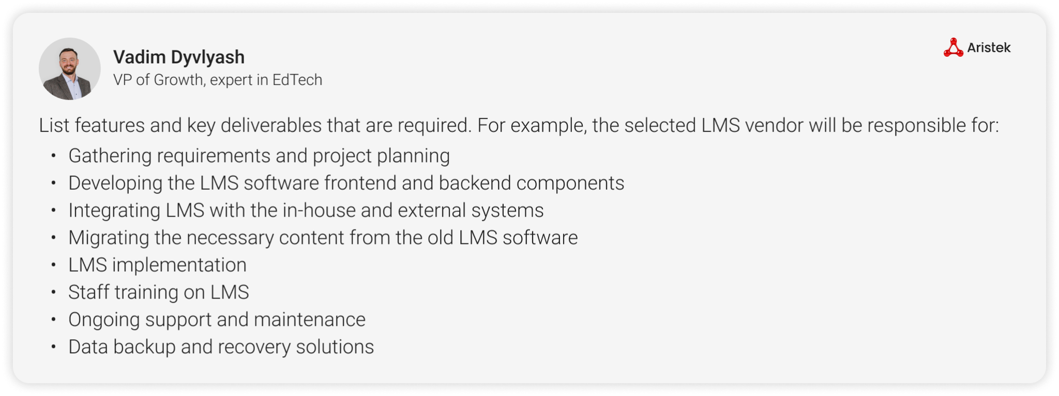

The desired start date for the project is Enter text, 20___, with a tentative duration of Enter text and ending on or about Enter text, 20___.

# LMS requirements

| LMS requirement | Description | Yes/No |
| --- | --- | --- |
| Cloud-based platform (on-premises or other depending on your decision) | LMS has to be hosted on a scalable and reliable cloud infrastructure. | Yes |
| Mobile application availability | Mobile app availability for every device you support (iOS, Android, etc.). | Yes |
| Standards compliance | LMS has to support SCORM, comply with WCAG level AA, and other national and international standards. | Yes |
| Customizable UI/UX | Flexible UI/UX that can be adapted to eLearning needs. | Yes |
| Scalability | The platform has to handle a growing number of users and content without storage limitations or productivity decrease. | Yes |
| Interoperability | Compatibility with various eLearning standards and protocols (SCORM, xAPI, cmi5, etc.). | Yes |
| Data migration | The vendor has to manage the migration of existing data to the new LMS, ensuring data integrity and compliance with relevant regulations. | Yes |
| Content & user management | Advanced user management capabilities (roles, permissions, groups), easy content creation, upload, and management. | Yes |
| Single Sign-On | Support for SSO | Yes |
| Reporting and analytics | Advanced reporting and analytics features. | Yes |
| AI features | AI-powered solutions operating within the LMS platform: content generators, customer support chatbots, etc. | Yes |
| Support services | Describe the support options available to technical staff: availability, response time, escalation factors, etc. | Yes |

## Data privacy and security

The vendor has to implement robust network security measures, such as Enter text, Enter text, Enter text. To guarantee the confidentiality, availability, and integrity of all data, the LMS must abide by all applicable data protection laws and regulations, e.g., GDPR, FERPA, Data Protection Act.

Regular auditing and real-time monitoring are required as a part of the service to identify and fix any security flaws or compliance problems.

1. The vendor should create a thorough data backup and disaster recovery plan to ensure business continuity.
2. The vendor should provide specifics about the security measures in place to preserve data integrity and how you make adjustments as necessary.
3. Explain your security auditing practices, including how you notify clients about security threats and demonstrate that vulnerabilities have been fixed.
4. Describe the data security-ensuring encryption mechanism used for data transmission and authentication.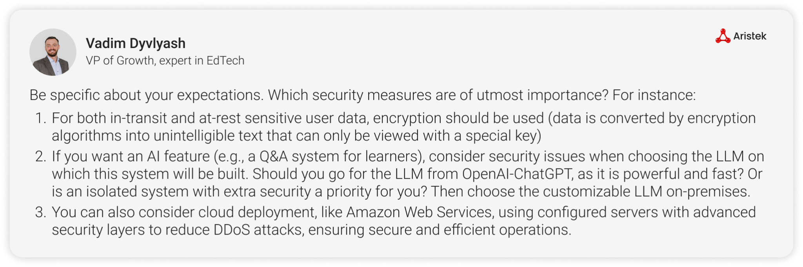

## Performance benchmarks

The following benchmarks are suggested for measuring and maintaining high system performance:

| Indicator | Metric | Significance |
| --- | --- | --- |
| Response time | Enter value ms (e.g., <1000) during heavy traffic |  |
| System uptime | Enter value % |  |
| Scalability | Enter value concurrent users must be handled by the system |  |
| Latency | Enter value (e.g., AI predictions) |  |
| Model accuracy | Enter value % |  |

# 

# Costs and budget

Provide a detailed cost breakdown that includes LMS Enter text, Enter text, Enter text, Enter text expenses. Any extra fees ought to be made explicit.

The proposal should specify the conditions of payment, including any payment milestones.

# Proposal guidelines

The following benchmarks are suggested for measuring and maintaining high system performance:

## Proposal format and structure

| Contact information | The potential solution provider should provide the name, job title, phone number, and email. Enter value is not responsible for incorrect contact information supplied by the vendor. |
| --- | --- |
| Executive summary and qualifications | The potential vendors have to introduce themselves and your business in this section, along with any relevant experience, examples of work, and credentials you may have. |
| Project roadmap | Create a comprehensive roadmap with a thorough timeline of milestones to ensure clear communication and accountability throughout the project, track progress, and make any necessary adjustments as needed. |
| Methodology | Explain your approach, capabilities to meet project objectives, and strategy for carrying out and finishing the project. |
| Communication plan | To guarantee project progress and completion, establish a communication plan outlining your intended methods of communicating both internally and with project managers. |
| Technical stack and solution architecture | Mention all the tools and technologies used to develop an LMS. |
| Team composition | Describe the team composition and expertise of individuals working on a project. |
| Budget and costs | Both a summary of the project's total proposed costs and a thorough breakdown of all expected expenses should be included. |
| Service Level Agreements | Include any service level agreements that outline the expectations and responsibilities of both parties involved in the project. |
| References | Provide Enter value (number) references for previous work of a similar nature. Please confirm that each reference is willing to participate in a reference check call and inform the reference they may be contacted by a company representative. |
| Risk management strategy | Provide a thorough risk management plan, including a disaster recovery plan to ensure business continuity. |
| Security and quality assurance | Describe procedures and security measures to ensure that the LMS platform is safe, reliable, and free from vulnerabilities. |

## 

## Evaluation criteria

Based on the documents supplied, any submissions that satisfy the RFP's specifications and are made by the deadline will be taken into consideration. The winning offer will be chosen based on the following criteria:

1. Use of correct format
2. Vendor’s qualifications and experience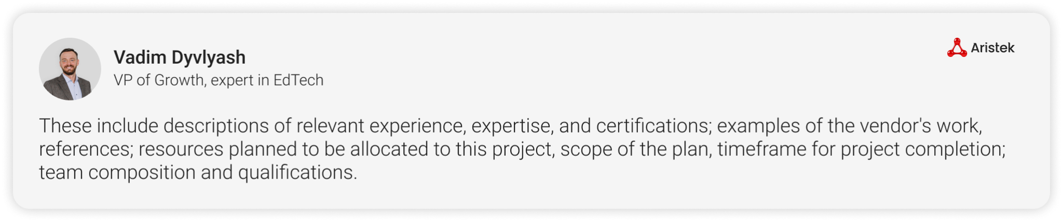
3. Proposed technical methodology
4. Project management
5. Alignment with project objectives and scope
6. Cost-effectiveness
7. Long-term partnership potential
8. Risk mitigation strategies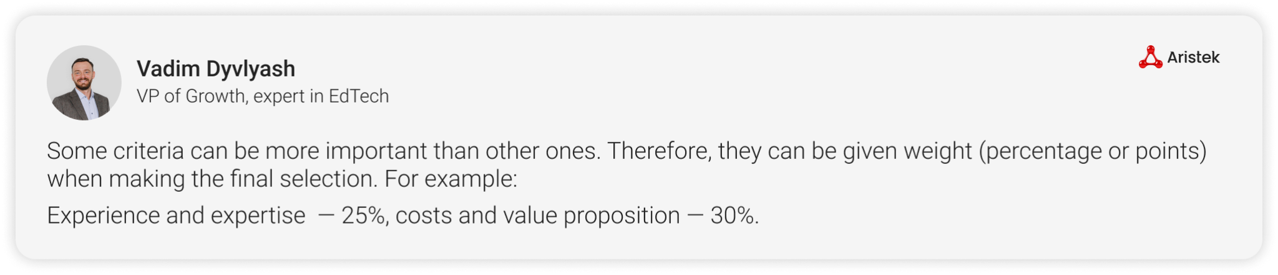

## RFP timeline

1. RFP initiation: Enter text
2. Vendor clarification questions deadline: Enter text
3. Answer clarification questions: Enter text
4. Proposal submission deadline: Enter text
5. Vendor selection: Enter text
6. Contract negotiation completion: Enter text
7. Project start: Enter text
8. Project completion: Enter text

## Contact information

Please use the email address below to submit your proposals in Enter text (e.g., PDF) format. For any questions or concerns that are not addressed in this proposal, please contact us via any of the following means.

1. Company name: Enter text
2. Address: Enter text
3. Phone: Enter text
4. Email address: Enter text
5. Website: Enter text

# Terms and conditions

The terms and conditions of the contract will be negotiated after the vendor selection. The Enter text legal department will analyze all contractual terms and conditions, including scope, budget, timeline, and other project-related requirements.

Any intellectual property developed during the project will be the property of our organization. The vendor must sign an NDA and agree to keep all project-related information confidential.

